Introduction

Here, we will create two notebooks,
- Conditional Workflow without LLM
- Conditional Workflow with LLM

Conditional Workflow without LLM

Here, we will create a workflow to solve a quadratic equation. We will give a quadratic equation, calculate discriminant and based on the value of discriminant D, we will move to any one node.
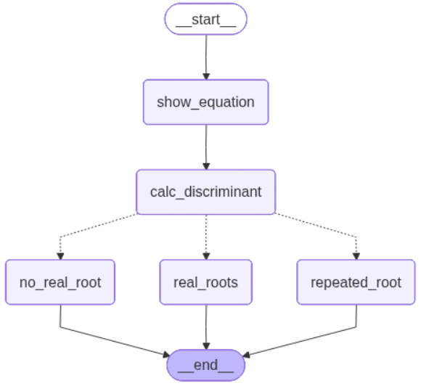
Two roots is known as ‘real roots’
One root is known as ‘repeated roots’

Discriminant (d) = $b^{2}-4ac$
Equation = $x^{2}-5x+6=0.$
d = $5^{2}-4\left(1\right)\left(6\right)= 25 - 24 = 1$
Here, d>0, hence we will get two roots
Use Formula:

Conditional Workflow with LLM

Here, we will create a workflow to give response of user’s feedback using LLM. The steps are,
- Find sentiment of the review.
- If sentiment is positive, revert accordingly.
- If sentiment is negative, find
  - Issue type
  - Tone (Calm, irritative, aggressive etc)
  - Urgency of the issue.
  - Revert accordingly
- END

